Name:CH.Nanda kishore
Roll No:2303A51638
BATCH:23
Lab Assignment 8
Task Description #1 (Username Validator – Apply AI in
Authentication Context)
- Task: Use AI to generate at least 3 assert test cases for a function is_valid_username(username) and then implement the function using Test-Driven Development principles.
- Requirements:
o Username length must be between 5 and 15 characters. o Must contain only alphabets and digits. o Must not start with a digit. o No spaces allowed. Example Assert Test Cases:
assert is_valid_username("User123") == True assert is_valid_username("12User") == False assert is_valid_username("Us er") == False Expected Output #1:
• Username validation logic successfully passing all AI- generated test cases.
Code:
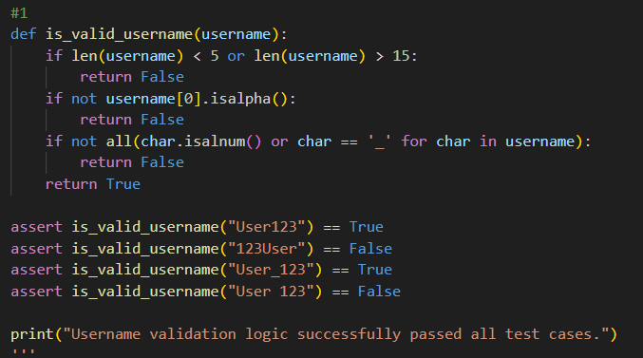
Output:

Task Description #2 (Even–Odd & Type Classification – Apply
AI for Robust Input Handling)
- Task: Use AI to generate at least 3 assert test cases for a function classify_value(x) and implement it using conditional logic and loops.
- Requirements:
- If input is an integer, classify as "Even" or "Odd".
- If input is 0, return "Zero".
- If input is non-numeric, return "Invalid Input".
Example Assert Test Cases:
assert classify_value(8) == "Even" assert classify_value(7) == "Odd" assert classify_value("abc") == "Invalid Input" Expected Output #2:
• Function correctly classifying values and passing all test cases.
Code:
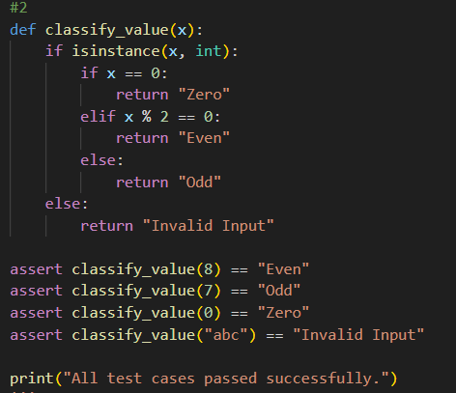
output :
# Task Description #3 (Palindrome Checker – Apply AI for
# String Normalization)
# • Task: Use AI to generate at least 3 assert test cases for a # function is_palindrome(text) and implement the function.
# • Requirements:
# o Ignore case, spaces, and punctuation. # o Handle edge cases such as empty strings and single # characters.
# Example Assert Test Cases:
# assert is_palindrome("Madam") == True
# assert is_palindrome("A man a plan a canal Panama") ==
# True
# assert is_palindrome("Python") == False # Expected Output #3:
# • Function correctly identifying palindromes and passing all # AI-generated tests.
CODE:
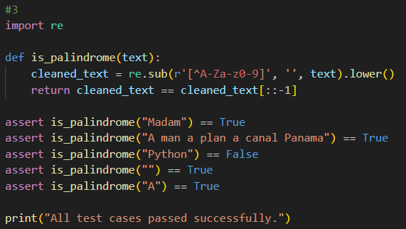
Output :
# Task Description #4 (Email ID Validation – Apply AI for Data
# Validation)
# • Task: Use AI to generate at least 3 assert test cases for a # function validate_email(email) and implement the function.
# • Requirements:
# o Must contain @ and .
# o Must not start or end with special characters.
# o Should handle invalid formats gracefully.
# Example Assert Test Cases:
# assert validate_email("user@example.com") == True
# assert validate_email("userexample.com") == False
# assert validate_email("@gmail.com") == False # Expected Output #5:
# • Email validation function passing all AI-generated test cases # and handling edge cases correctly.
CODE:
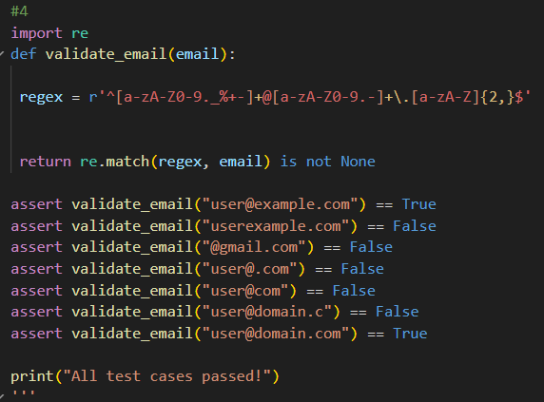
Output :
# Task 5 (Perfect Number Checker – Test Case Design) # • Function: Check if a number is a perfect number (sum of # divisors = number).
# • Test Cases to Design:
# o Normal case: 6 → True, 10 → False.
# o Edge case: 1.
# o Negative number case.
# o Larger case: 28.
# • Requirement: Validate correctness with assertions.
CODE:
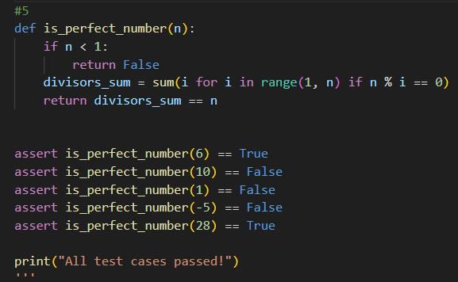
Output :
# Task 6 (Abundant Number Checker – Test Case Design) # • Function: Check if a number is abundant (sum of divisors > # number).
# • Test Cases to Design:
# o Normal case: 12 → True, 15 → False.
# o Edge case: 1.
# o Negative number case.
# o Large case: 945.
# Requirement: Validate correctness with unittest
CODE:
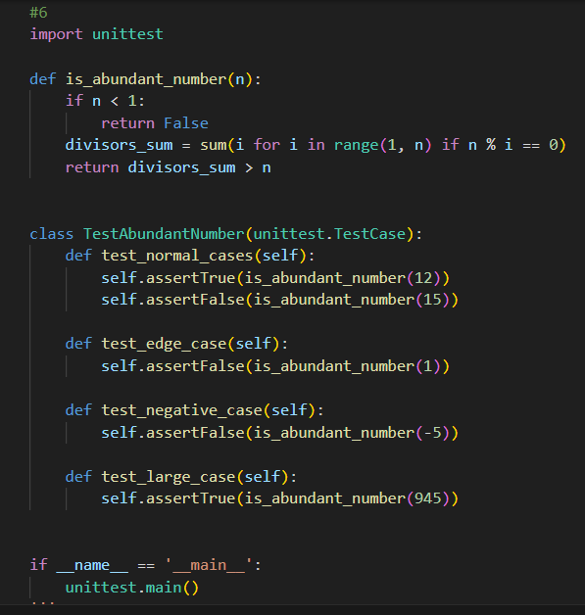
Output :
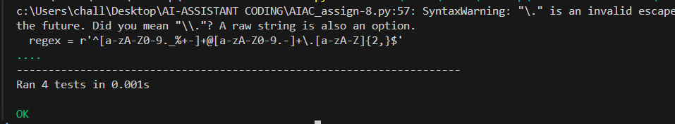
# Task 7 (Deficient Number Checker – Test Case Design) # • Function: Check if a number is deficient (sum of divisors < # number).
# • Test Cases to Design:
# o Normal case: 8 → True, 12 → False.
# o Edge case: 1.
# o Negative number case.
# o Large case: 546.
# Requirement: Validate correctness with pytest.
CODE:
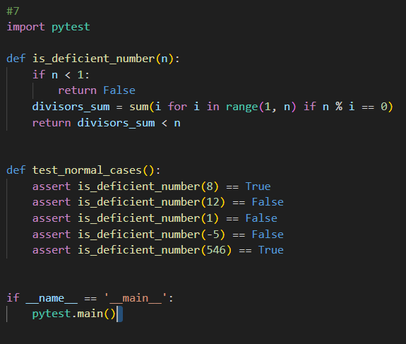

Output :
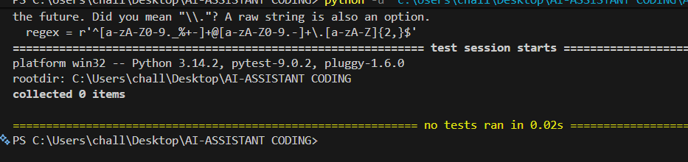
# Task 8 :
# Write a function LeapYearChecker and validate its implementation
# using 10 pytest test cases
CODE:
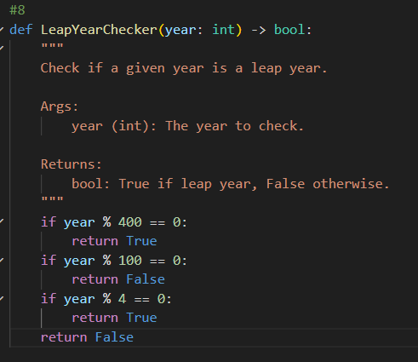
Output :
All test cases passed!
# Task 9 :
# Write a function SumOfDigits and validate its implementation # using 7 pytest test cases.
CODE:
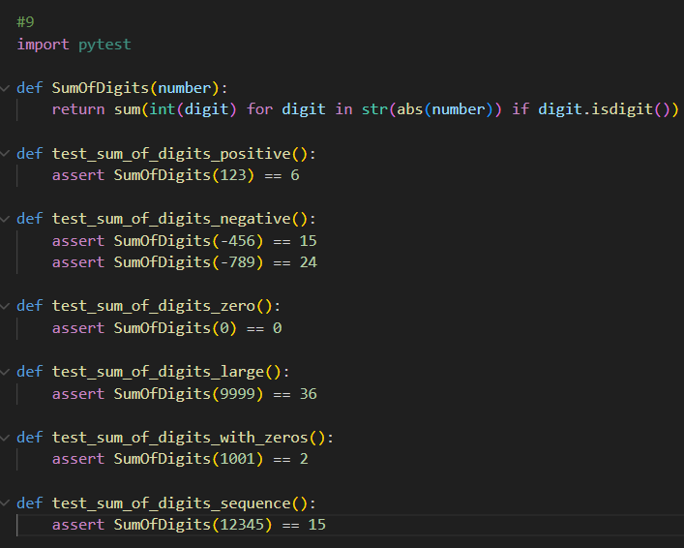
Output :
All test cased are passed!
# Task 10 :
# Write a function SortNumbers (implement bubble sort) and validate # its implementation using 25 pytest test cases.
CODE:
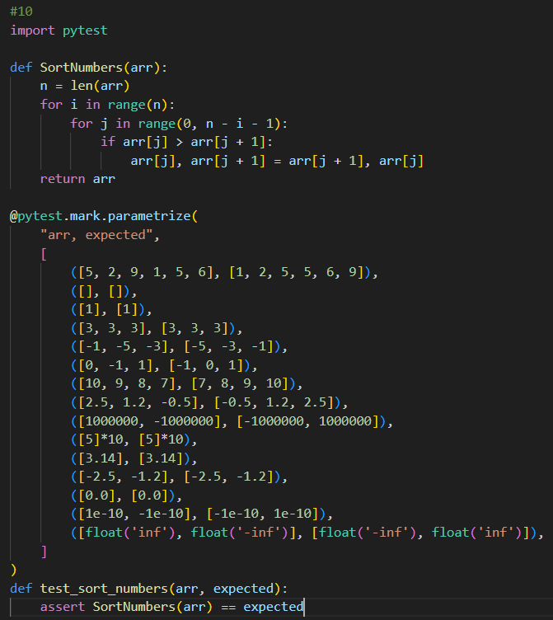
Output :
All test cases passed!
# Task 11 :
# Write a function ReverseString and validate its implementation
# using 5 unittest test cases import unittest
CODE:
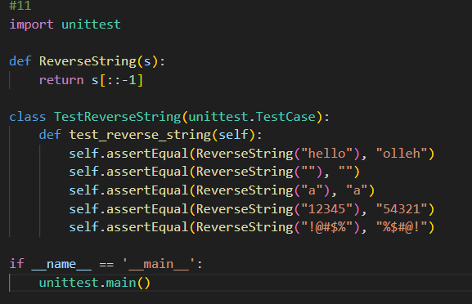
Output :
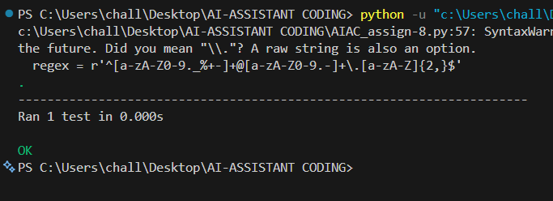
# Task 12 :
# Write a function AnagramChecker and validate its implementation # using 10 unittest test cases.
CODE:
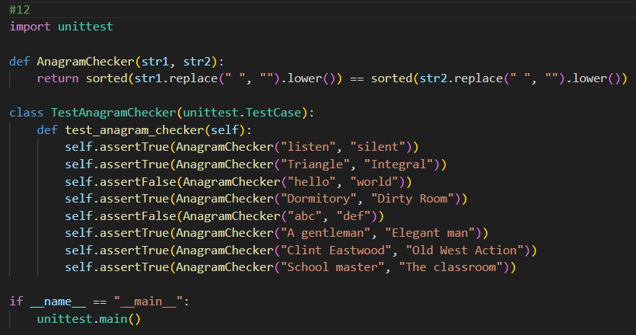
Output :
All test cases passed!
# Task 13 :
# Write a function ArmstrongChecker and validate its implementation # using 8 unittest test cases.
CODE:
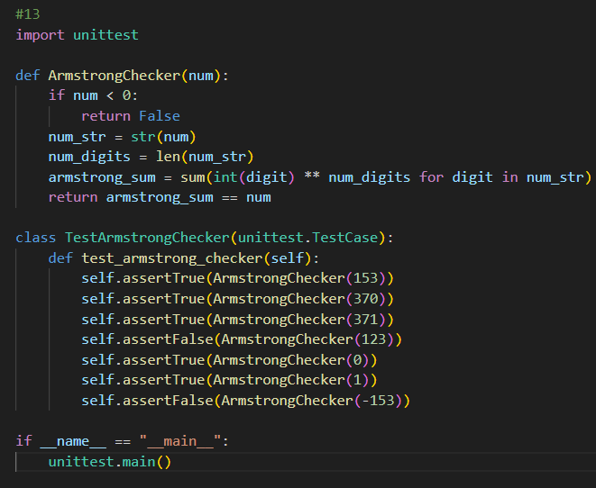
Output :
All test cases passed!

